Sennheiser joins North American Spectrum Alliance
Audio technology innovator emphasizes the need for joint action to safeguard spectrum for content production and delivery

Wedemark/Old Lyme/Toronto, February 24, 2025 – Sennheiser today announced that the company has joined the North American Spectrum Alliance, a project of the non-profit North American Broadcasters Association (NABA) committed to identifying and taking action on technical and operational issues affecting radio and television broadcasters in Canada, Mexico and the United States. The alliance unites broadcasters, rightsholders, venues, and the entertainment industry to protect the critical radio spectrum used for broadcasting, wireless microphones, cameras, and other production tools – a goal that Sennheiser has been actively pursuing, too, both as a company and as a member of various associations.



The North American Spectrum Alliance presents a strong, unified voice for spectrum retention in a broadcast and production environment that is marked by recent spectrum reallocations and plans for potential additional UHF auctions. With ongoing encroachment from mobile services (IMT) and unlicensed devices, the association takes action to safeguard the resources that power content creation and delivery.

Rebecca Hanson, Director-General of NABA says, “We believe that users of media spectrum in North America need to band together to defend all aspects of spectrum that the industry needs, and wireless audio is an essential part of this effort. We are delighted to welcome Sennheiser as a new member to the North American Spectrum Alliance. Their long-standing global advocacy for radio spectrum and leadership in wireless technologies will significantly strengthen our collective efforts.”

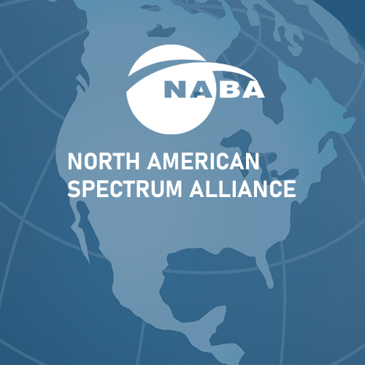 | The North American Spectrum Alliance unites broadcasters, rightsholders, venues, and the entertainment industry to protect the critical radio spectrum

Dr. Andreas Wilzeck, Head of Spectrum Policy and Standards at Sennheiser, emphasizes that Sennheiser’s commitment extends beyond technology, with the company fostering close collaborations with customers, end users, partners, industry leaders, and regulatory bodies: “Our strategy revolves around forging meaningful alliances across industries, actively participating in standardization efforts, and engaging in regulatory discussions. This approach allows us to effectively articulate and serve common interests, ultimately driving progress for our customers and the entire audio industry. Joining the North American Spectrum Alliance is a natural progression of this commitment, and we hope our decision will inspire others to follow suit.”

For Joe Ciaudelli, Director of Spectrum and Innovation for Sennheiser in the USA, collaboration is key, too: “We firmly believe in the strength of collective action as we safeguard the TV-UHF band, which stands as the world’s most successful spectrum sharing ecosystem. Simultaneously, we’re actively pursuing additional frequency options and spearheading technological innovations like WMAS to fuel growth. This unified approach is not just important—it’s imperative. We cannot afford fragmentation among various interest groups. NABA’s initiative in bringing stakeholders together is commendable, and we’re fully committed to this collaborative journey.”

Protect (that which creates) what you love
While the term “spectrum” may sound abstract for many people, it is a prerequisite for creating, experiencing and disseminating the content and live events we all have come to love. Spectrum enables the content that mobile and streaming services rely on. Wireless technology is behind the concert of a mega-star or an intimate gig in a club; it delivers the passion and excitement of sports to fans across the globe. Celebrations, theatre performances, live events, theme parks, exhibitions – all have come to rely on wireless to immerse their guests in a vivid, captivating experience. Entertainment, news gathering, exciting movies, documentaries: they are produced using wireless technology. Behind all of this is the radio spectrum – a resource that is as finite as it is precious, and which is harnessed with expertise and care by professional users.

 | 
Spectrum is a prerequisite for unforgettable live performances, broadcasts and productions

Join to make a difference
Rebecca Hanson extends an invitation: “We welcome all users of media spectrum, be they large or small, to join the Spectrum Alliance. Together, we can protect the future of wireless content creation.”

Visit https://nabanet.com/naspa/ for more information. To inquire about joining the Spectrum Alliance, please contact Rayne Morgan at rayne@nabanet.com. Membership in NABA is not required to join the Alliance.

(Ends)

The high-resolution images accompanying this media release can be downloaded here.

About the Sennheiser brand
We live and breathe audio. We are driven by the passion to create audio solutions that make a difference. Building the future of audio and bringing remarkable sound experiences to our customers – this is what the Sennheiser brand has represented for more than 75 years. While professional audio solutions such as microphones, meeting solutions, streaming technologies and monitoring systems are part of the business of Sennheiser electronic SE & Co. KG, the business with consumer devices such as headphones, soundbars and speech-enhanced hearables is operated by Sonova Holding AG under the license of Sennheiser.

www.sennheiser.com
www.sennheiser-hearing.com

Global Pro Audio Press Contact
Stephanie Schmidt
stephanie.schmidt@sennheiser.com
+49 (5130) 600 – 1275

